

Airbnb

**ISTM 6202 Team Project**

**Team 02**

Esther Jeong

Pa Alimamy Bangura

Mallika Yadav

Amber Grayson

Tingli Wang

# 

**Table of Contents**

Executive Summary 1

Section I: Business Problem 2

1.1 Description of Organization and Its Problem(s) 2

1.2 As-IS Business Process Map 5

1.3 Conceptual Database Design (As-IS ERD) 7

Section II: IT-Based Solution Development 8

2.1 Description of IT-based Solution 8

2.2 To-Be Business Process Map 9

2.3 Conceptual Database Design (To-Be ERD) 11

2.4 Business Function to Data Entity Matrix 13

2.5 Logical Database Design 13

Section III: Database Implementation 14

3.1 Physical Database Design 14

3.2 Create Database 17

References 28

# Executive Summary

In the ever-evolving landscape of global lodging and travel, Airbnb has proactively addressed multifaceted challenges, including regulatory complexities, trust issues, quality control, market competition, and operational scalability. This report sheds light on Airbnb's strategic responses to these challenges, highlighting its adaptability and commitment to user-centric solutions which will be expounded upon in the following sections of this report.

A pivotal aspect of Airbnb's strategic vision is the introduction of a Loyalty Program. This program, intricately designed around the 5C's framework (Capture, Convey, Create, Cradle, Communicate), is poised to revolutionize user engagement. Through comprehensive data capture, personalized communication, dynamic tier structures, and secure data cradling, Airbnb seeks to create a loyalty ecosystem that benefits both guests and hosts.

The conceptual, logical, and physical dimensions of the Loyalty Program's database design underscore Airbnb's commitment to robust data management. The Entity-Relationship Diagram (ERD) seamlessly integrates loyalty components into Airbnb's existing data framework, reflecting a forward-thinking approach to technology integration.

The SQL statements, constituting the physical implementation of the database, exemplify the system's versatility. From booking information retrieval to loyalty point calculations, the database demonstrates a capacity to handle diverse tasks. Sample queries offer insights into its capabilities, showcasing a system designed for efficiency and flexibility.

In summary, the Loyalty Program initiative is positioned as a testament to Airbnb’s resilience and innovation in the hospitality and travel sector. It is not only overcoming challenges but also positions the platform as an innovator. By intertwining strategic solutions with a cutting-edge Loyalty Program, Airbnb aspires to fortify user engagement, instill brand loyalty, and emerge as a stalwart in an industry marked by dynamic shifts and intense competition. This comprehensive approach underlines Airbnb's commitment to delivering unparalleled experiences and setting new standards in the global travel marketplace.

# Section I: Business Problem

## 1.1 Description of Organization and Its Problem(s)

**INTRODUCTION OF THE ORGANIZATION**

Airbnb, founded in 2008, is a growing prominent worldwide platform facilitating lodging and travel experiences for travelers. It began when two designers saw an upcoming conference in San Francisco with limited hotel availability. They decided to open their space to host travelers looking for a place to stay to earn some extra money. They created a simple site, airbedandbreakfast.com, bought three air mattresses and arranged them in their loft. Their first guests, two men, and one woman, showed up (Insider, 2019). It was at that moment that Airbnb was born. Airbnb’s purpose is clearly defined in its mission statement: “Airbnb’s mission is to create a world where anyone can belong anywhere, and we are focused on creating an end-to-end travel platform that will handle every part of your trip”. Their current business process and model include two different types of customers. The host can offer their homes or properties to people and guests looking for places to stay in specific areas. It is important to look at the value for each type of customer. The host can make money by renting out their properties through the app and can manage bookings, view profiles of renters, and update listings all while receiving 24 hours a day, seven-days-a-week support via phone, email, and chat with Airbnb. As a guest, you can save money on rent and have the convenience of searching for listings, browsing specific areas, and inputting filters with the ability to manage and book right within the app (The Business Model Analyst, 2023). Airbnb has transformed the travel industry by connecting travelers with unique lodging experiences globally.

**PROBLEM/OPPORTUNITY**

One of the main problems we identified for Airbnb is the lack of a loyalty program. This issue impacts various aspects of the business that if left unaddressed, could hinder Airbnb's growth. This gap could lead to users exploring alternatives and increased competition from other travel platforms. While Airbnb has built trust through its rating and review system, it lacks tangible incentives for frequent use, common in traditional loyalty programs offered by hotels and other travel agencies. While the absence of a loyalty program presents a significant challenge for Airbnb and its potential hindrance to growth, it's essential to understand the broader context of loyalty programs' effectiveness in the hospitality sector. In an article published by a lodging magazine, they found that loyalty contribution is continually rising year after year. As shown below, (**Figure 1)** “Year-to-date through June 2019, the percentage of total room nights booked by members of brand loyalty programs increased 4.4 percent year-over-year (YOY) to 53.9 percent of all room nights booked at hotel brands with existing loyalty programs” (Lodging, 2019). This data underscores the vital role loyalty programs play in the success of businesses in the lodging industry.

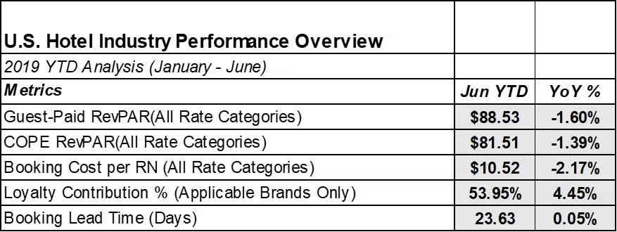

**Figure 1**

From a strategic business perspective, the absence of a loyalty program has far-reaching implications for hosts and guests. Without such a program in place, Airbnb misses a valuable opportunity to not only reward and retain its most devoted patrons but also to significantly boost its revenue streams. A notable study by Cornell University, as reported in the Trivago Business Blog, investigated the economic impact of loyalty programs, particularly within the realm of independent hotels. They found that ‘the number of annual room nights for each guest increased by nearly 50 percent.’ When occupancy rates increase that significantly, revenue rises and costs fall.” (Trivago Business Blog, 2017). Their findings revealed a remarkable statistic: the number of annual room nights for each guest surged by nearly 50 percent when loyalty programs were in play. Such a surge in occupancy rates translates directly to increased revenue and cost savings. It also would help with the current limited ability to retain customers. It would incentivize guests to return to Airbnb for their accommodation needs, increasing customer lifetime value and providing a benefit to the hosts who also increase their revenue. The chart below **(Figure 2)** includes findings from Marriott, Hilton, Hyatt, Wyndham, and Choice public filings showing that loyalty program members per room continued to increase even during the pandemic (CBRE, 2023).

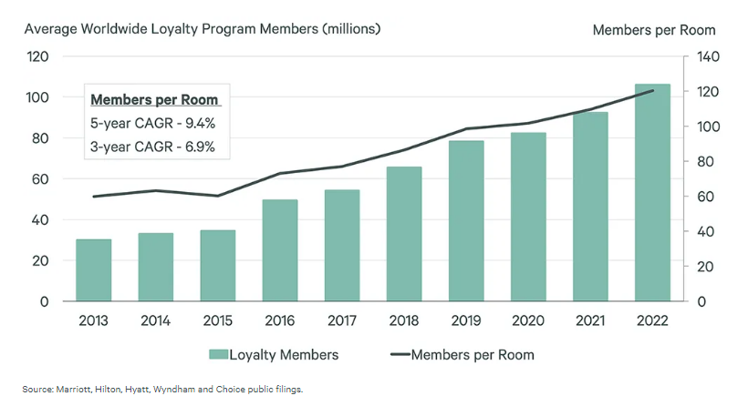  
**Figure 2**

In an article written for Forbes magazine, Jia Wertz argues that loyalty programs give customers incentives or benefits and develop a connection between organizations and their customers (Wentz,2021). Customers will become brand ambassadors for the company, which will help create more customers and eventually increase revenue. A 2019 global blind survey by Salesforce reported that 78% of customers would transact with companies with loyalty programs (Salesforce,2019). Companies with curated loyalty programs can retain customers and increase revenues and profits. Loyalty programs are potential future investments that can generate the following benefits for the company: An increase in the number of bookings and reduced marketing costs due to loyalty members becoming brand ambassadors, customers being less attracted to promotions from other competitors, loyalty members spending more as compared to new member and less expensive to retain old customers than to attract new ones. The following diagram by Dziawgo illustrates the benefits of loyalty programs (Dziawgo,2023).

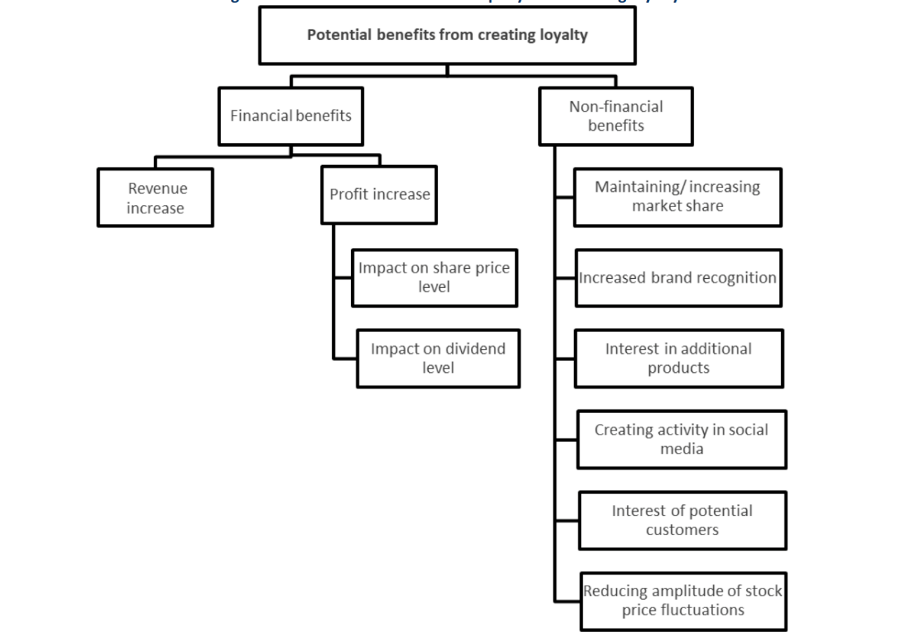

Therefore, loyalty programs curated for Airbnb will help boost investor confidence, increase customers, and increase earnings and profits. This loyalty program will help continue positioning Airbnb as the global leader in rental property, creating more host participation and guest satisfaction.

In conclusion, the absence of a loyalty program poses a significant challenge for Airbnb, impacting various facets of its business. To ensure sustained growth and competitiveness, Airbnb should consider implementing a loyalty program to incentivize and retain its most loyal customers, which would result in increased revenue opportunities and benefits for both guests and hosts. As evidenced by studies and the ongoing success of loyalty programs in the hospitality industry, this strategic move could be a game-changer for Airbnb, fostering customer loyalty, higher revenues, and overall business success.

## 1.2 As-IS Business Process Map

The As-Is business process map shows how the Airbnb system functions from the guest's initial interaction with the system to the user booking confirmation. The User Booking Process involves travelers searching for accommodations on Airbnb's platform, booking lodging based on their preferences, and hosts receiving and responding to booking requests. Guests and hosts also communicate to coordinate check-ins, check-outs, and other details. The Rating and Review System plays a critical role in building trust and reputation on the platform, as guests provide ratings and reviews after their stay, and hosts can also rate and review guests.

Customer Support is another significant process, with users reaching out to Airbnb's customer support through various channels, including email, phone, and the Help Center. Support agents assist with inquiries, issues, and disputes, but there can be variations in resolution times and the quality of support provided. Unfortunately, Airbnb currently lacks a formal Loyalty Program for rewarding and retaining loyal customers, which means there are no tangible incentives for frequent use of the platform.

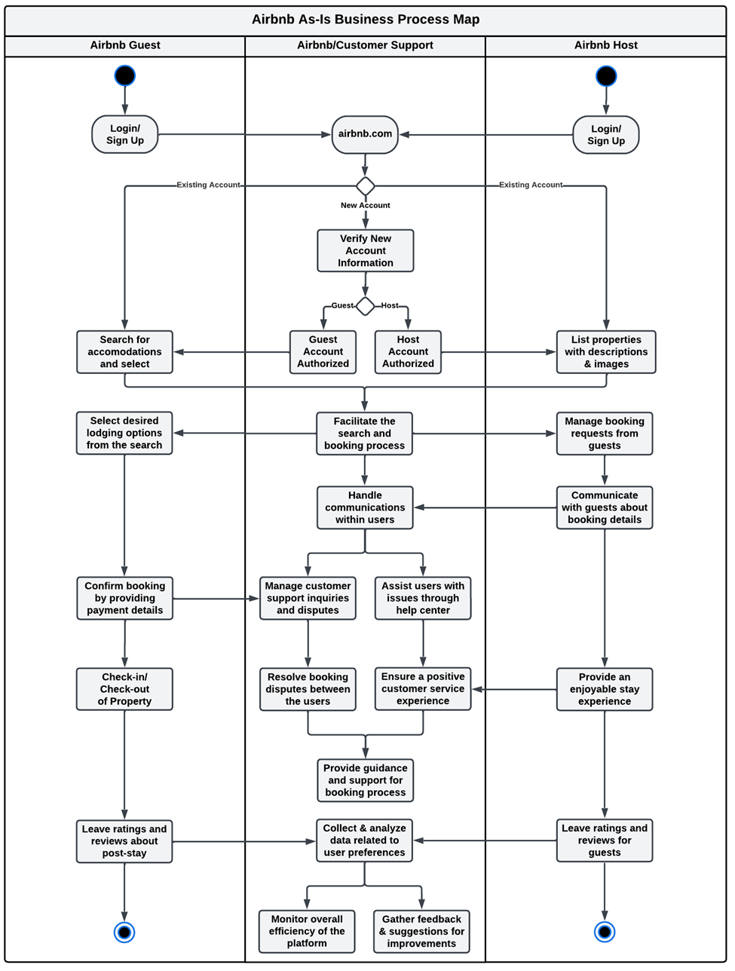

**Figure 1. As-Is Business Process Map**

## 1.3 Conceptual Database Design (As-IS ERD)

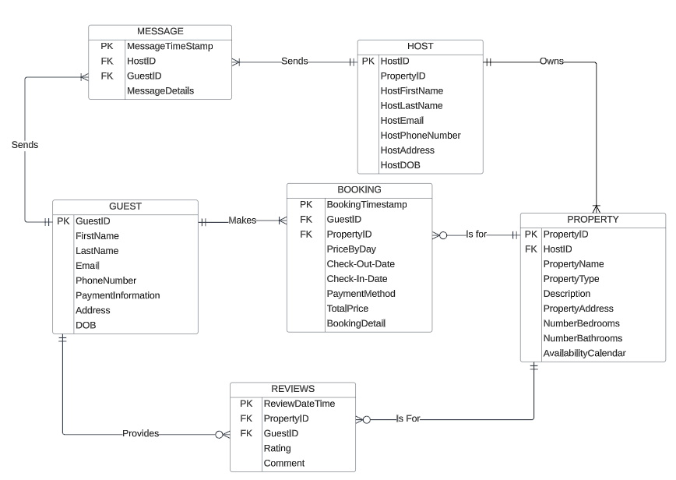

**Figure 2. As-Is ERD**

The Entity-Relationship Diagram (ERD) represents the data structure for Airbnb, a company that serves as a place to connect guests with property hosts. At its core, ERD comprises six principal entities integral to the operational efficacy of Airbnb's data architecture: User, Property, Booking, Reviews, Host, and Message, each composed of its distinctive attributes. Users can be Guests or Hosts, depending on whether they book properties or list properties delineated by the User Type attribute. Hosts can own multiple properties, and Users can book multiple properties, creating one-to-many relationships. Bookings connect Guests and Properties, storing information about check-in and check-out dates, prices, and status. Properties can have multiple bookings. Users can write multiple reviews for different properties allowing users to provide ratings and comments. Finally, a Message entity enables users (both hosts and guests) to communicate with each other, recording the user and host information, the message details, and a date/time stamp.

# Section II: IT-Based Solution Development

## 2.1 Description of IT-based Solution

A comprehensive IT-driven strategy suggested for Airbnb involves introducing an extensive Loyalty Program, which utilizes advanced data analysis and personalization techniques to acknowledge and maintain hosts and guests. This Loyalty Program is deemed essential due to the mounting competition Airbnb faces from emerging platforms offering similar services. Airbnb's current priority is to deliver outstanding service and secure customer loyalty. Therefore, integrating a loyalty program into the existing Airbnb platform, featuring a range of rewards and incentives for frequent users, serves as a solution to the identified issue of the absence of such a program.

A crucial element of this solution involves the development of the Loyalty Management System, designed to oversee the Loyalty Program. This system will monitor guest and host (users) actions, reservations, and interactions, enabling the calculation and distribution of loyalty points. Users will have the ability to check their points, rewards, and eligibility for exclusive privileges. Moreover, the program will employ advanced data analytics to gain insights into user preferences, resulting in tailored rewards, such as discounts on accommodations that align with a user's past choices. The Loyalty Program will offer a range of benefits, including reduced rates on future bookings, exclusive access to distinctive and sought-after properties, early booking options, priority customer support, and special offers during peak travel seasons, establishing a solid foundation for the program.

Guests will amass loyalty points for every booking and interaction within the platform, encompassing actions such as submitting reviews, length of stay, and actively participating in the Airbnb community. These accumulated points can be utilized to redeem rewards or ascend to higher loyalty tiers. To enhance user engagement, the system will maintain an active channel of communication with users, using methods like email, push notifications, and in-app messages, ensuring that they receive regular updates on their loyalty status, their accumulated points, and the available rewards at their disposal.

The Loyalty Program will smoothly integrate into the current Airbnb platform, simplifying the process for users to redeem rewards when making bookings. Additionally, loyalty program members will enjoy improved customer support, ensuring that their questions and concerns are promptly resolved. This comprehensive IT-driven solution is designed to not only tackle the identified issue but also promote customer loyalty, personalized experiences, and overall user satisfaction within the Airbnb environment.

## 2.2 To-Be Business Process Map

As illustrated in the To-Be model, users (guests and/or hosts) will log in and have the choice to enroll in the loyalty program. Upon registration, the system will automatically monitor users according to their actions, and rewards will be consistently enhanced. Both hosts and guests will be provided with the opportunity to accumulate points. There will be a separate loyalty ID assigned to guest and host.

Guests: Points will be earned based on the number of bookings made, the submission of reviews, and length of stay. The Loyalty Program will operate on a tiered structure and offer various advantages, including reduced rates for future bookings, exclusive access to unique and highly sought-after accommodations, early booking privileges, priority customer support, and special offers during peak travel seasons. This includes the opportunity for a complimentary stay, forming a strong foundation for the program. Members will also benefit from enhanced customer support to ensure swift resolution of their inquiries and concern

Hosts: Points will be acquired through hosting activities and receiving positive guest reviews. Progression through tiers will be determined by the points earned. Additionally, these earned points can be utilized for exclusive discounts, promotional placement, and even the possibility of enjoying a free Airbnb experience.

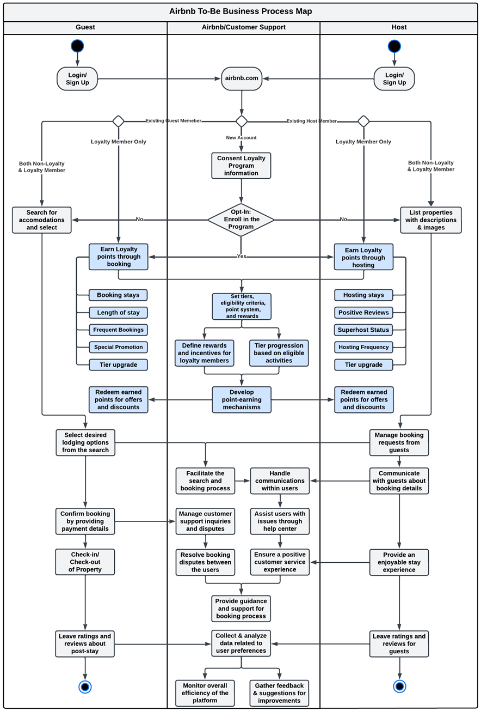

**Figure 3. To-Be Business Process Map**

## 2.3 Conceptual Database Design (To-Be ERD)

Our new loyalty program will support the 5c’s in the following ways:

1. **Capture:** When a user enrolls in the loyalty program, the database must capture a comprehensive set of user information, including full name, phone number, and mailing address. The system should also collect demographic details such as gender and date of birth. It must record user communication preferences, including email and text message notifications. Additionally, the database should store the information related to the payment methods associated with users’ loyalty program accounts, for smooth transactions and rewards management.
2. **Convey:** Users must be informed about the loyalty program's benefits, including points accrual, reward selections, and tier-specific privileges. The system should send updates to members about special promotions, exclusive offers, and reward redemption details. The system should provide comprehensive transaction confirmations, specifying points earned, redeemed, or expired. The system should send timely updates to users in advance of any impending points expiration.
3. **Create:** The system should process, critical information including a detailed transaction history related to the loyalty program. Members' activities and points accumulation through bookings, referrals, reviews, and other interactions must be meticulously tracked. Membership tiers should be dynamically adjusted based on members’ activities and earned points. An up-to-date record of each member’s points balance should be maintained.
4. **Cradle:** The database is responsible for securely storing essential data, including comprehensive member profiles featuring demographic information, communication preferences, and user account particulars. It must maintain an extensive transaction history, recording all member activities and interactions The repository should store critical data associated with points balances, earned points, redeemed points, rewards, and detailed redemption histories.
5. **Communicate:** Establish real-time data exchange between the loyalty program and Airbnb’s existing system for seamless communication and data sharing Ensure secure data sharing with third-party integration to support promotional activities and partnership, aiming for mutual benefits.

The Entity-Relationship Diagram (ERD) illustrates the data framework for Airbnb, a platform facilitating connections between guests and property hosts. In the To-Be-ERD, novel elements related to the loyalty program, such as Loyalty and Program Tiers have been incorporated. The system will store data according to user activities and monitor their ongoing advancement.

**Figure 4. To-Be ERD**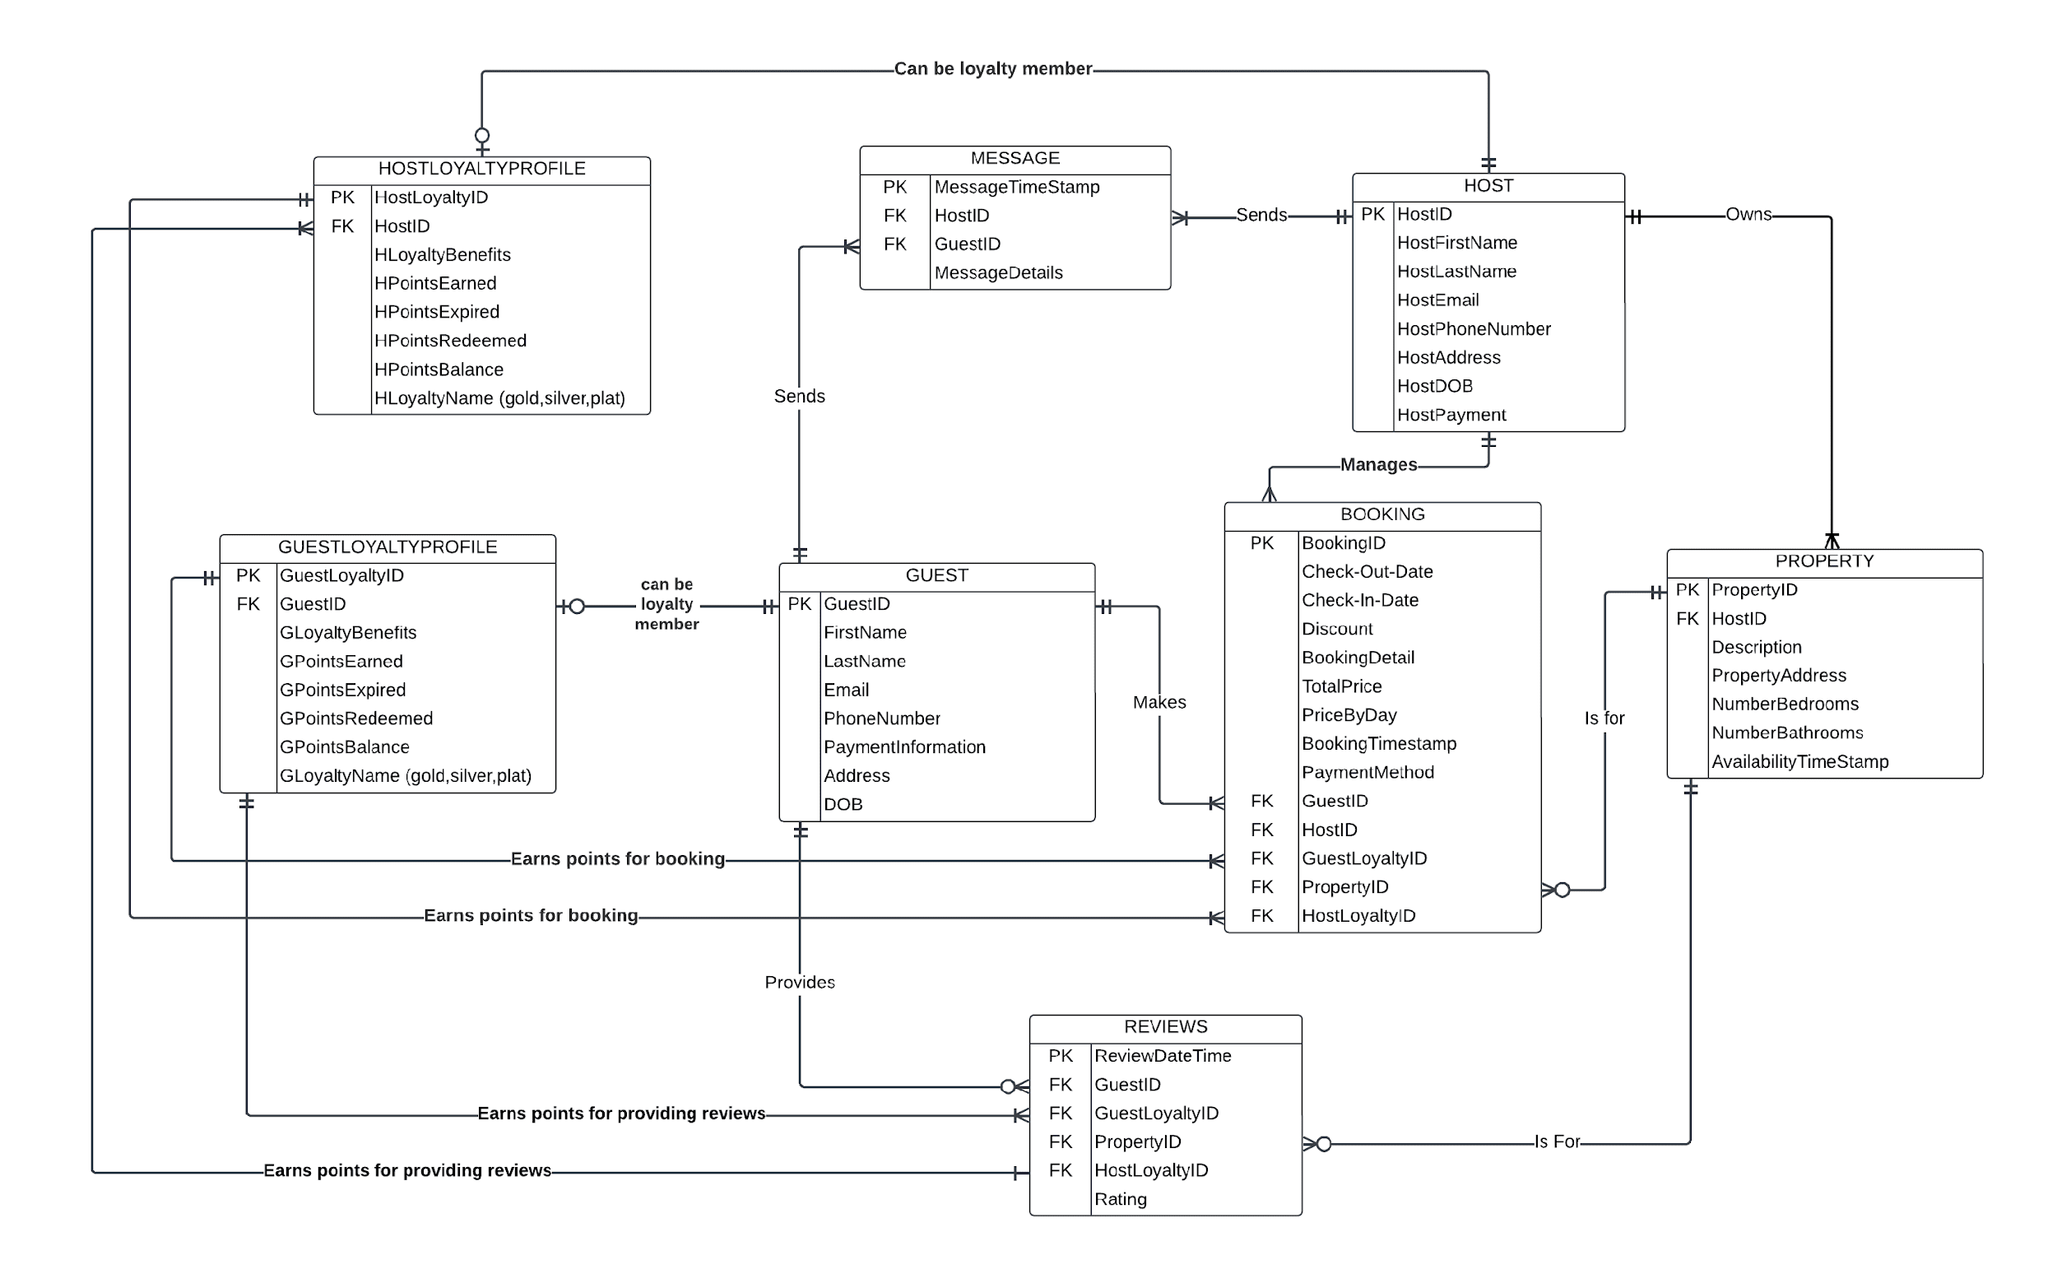

**Business Rules**

1. The loyalty program offers both the guests and hosts the choice to join the program.
2. Guest and Host Loyalty ID is issued only for members enrolled in loyalty program. The points are updated regularly in guest and host loyalty profile.
3. Every loyalty member's has loyalty name based on program tier. The loyalty name is modified upon reaching a specific tier requirement.
4. Points earned will expire if they remain unused for more than two years.
5. Loyalty hosts’ properties will be featured prominently compared to regular hosts’ properties.
6. Only one discount is applicable to a booking and cannot be combined with other discounts.
7. Guests’ can book only one stay for one check-in date and time.
8. Guests’ and hosts can send multiple messages to each other.
9. One host can have multiple properties listed on Airbnb websites.
10. All properties listed should have a unique Property ID number.
11. One property can be reserved for one check-in date and time.
12. Guests’ can write only one review for a booking with designated booking ID, check-in date and time.
13. Host will earn points on positive guests’ reviews and frequency of properties booked.
14. Guests will earn points on the number of check-ins they make and number of reviews they leave on Airbnb platform.

## 2.4 Business Function to Data Entity Matrix

The below matrix demonstrates how data entities are associated with business functions that are in the new loyalty program system:

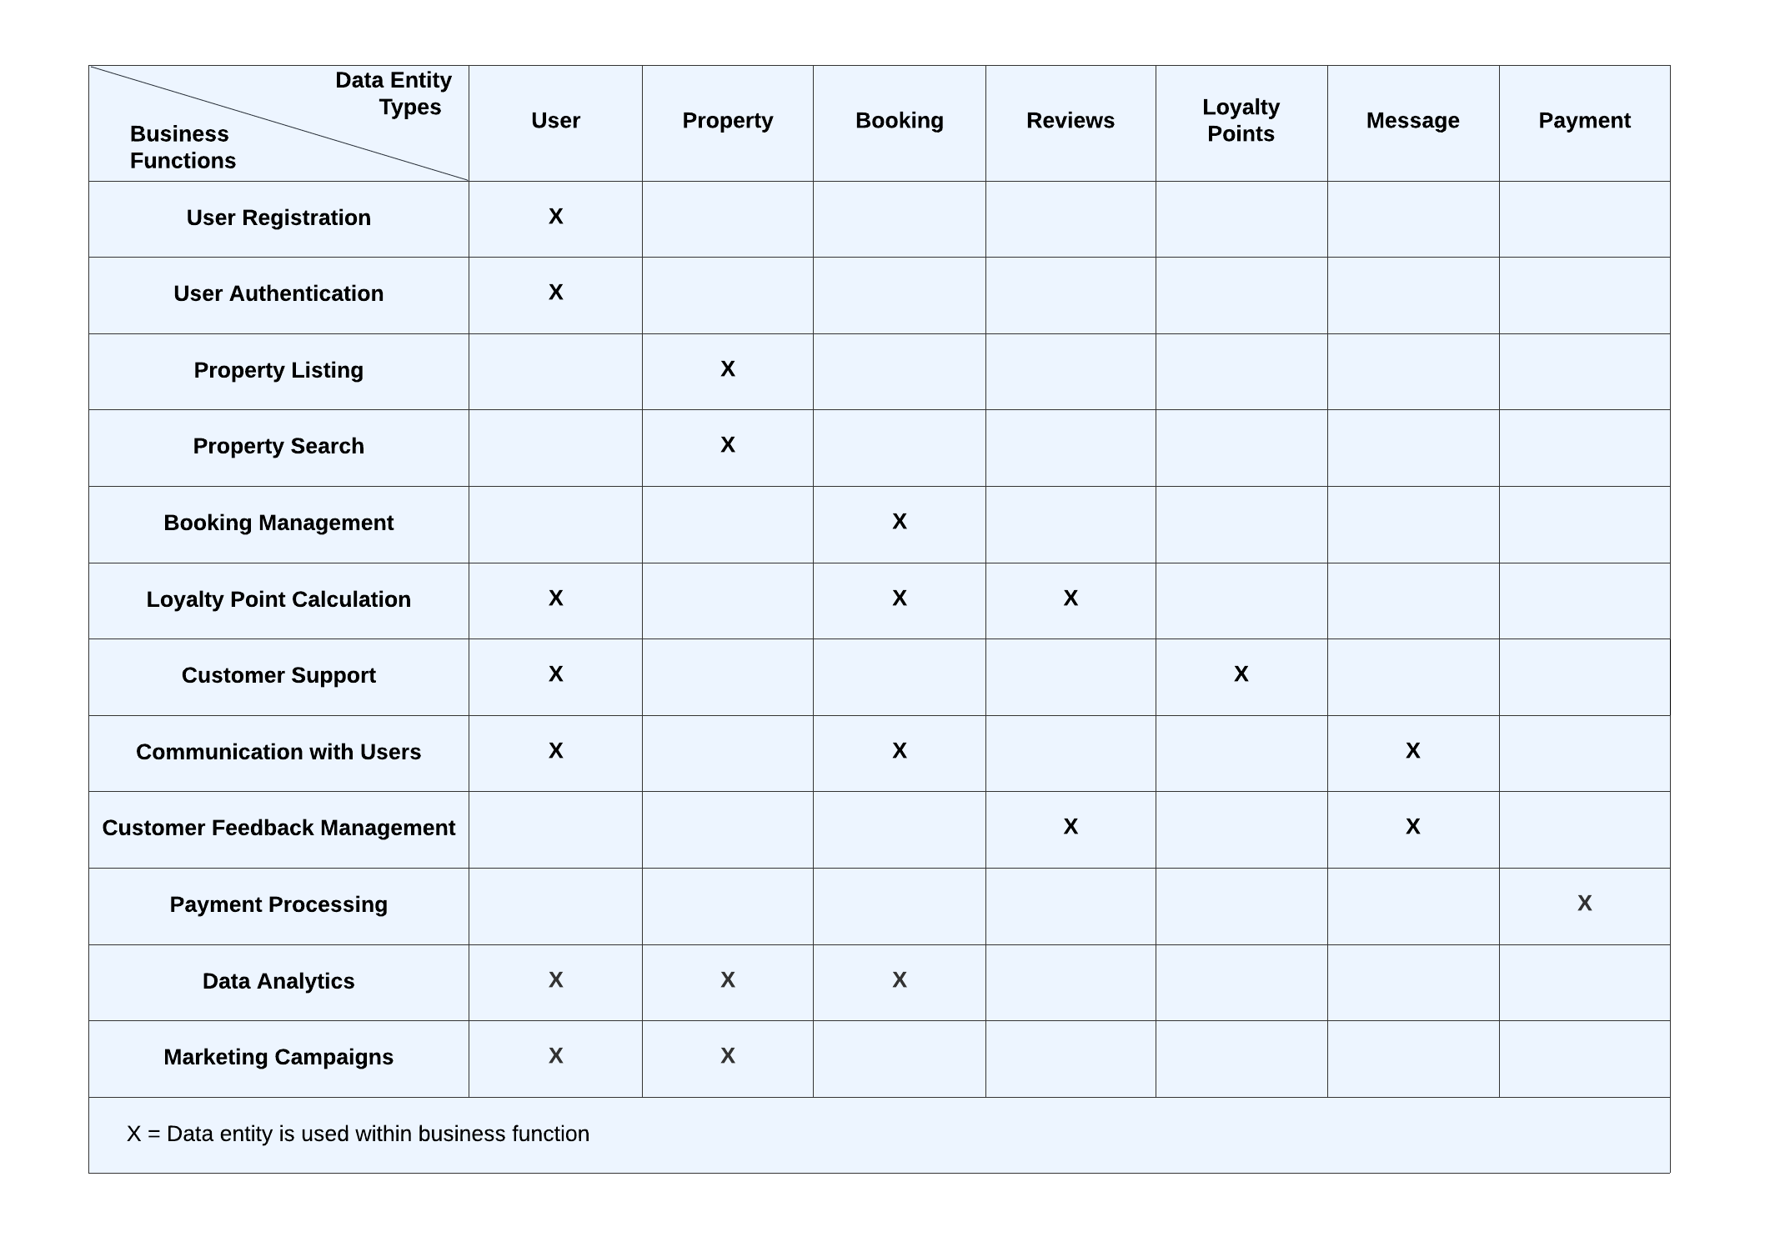

## 2.5 Logical Database Design

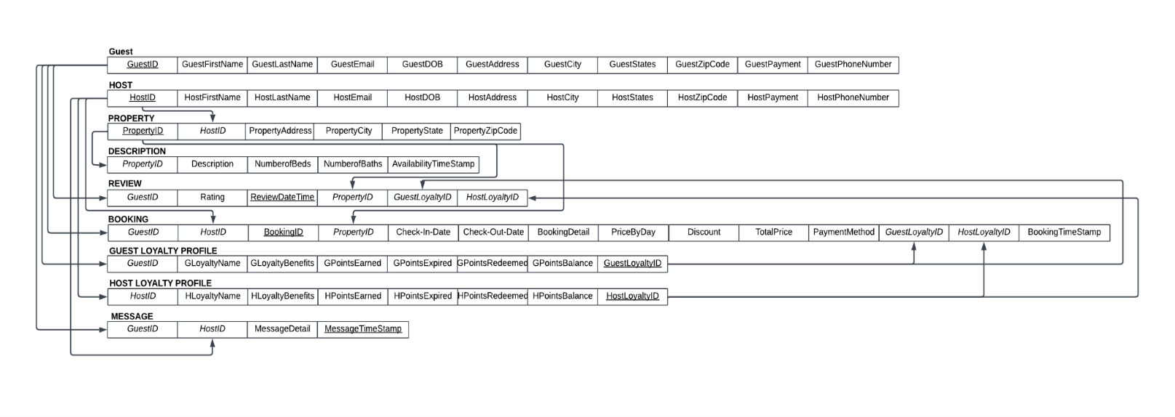By mapping the Entity Relationship Diagram (ERD) to relation and normalization, the 3NF Relational Schema is shown below:

# Section III: Database Implementation

## 3.1 Physical Database Design

CREATE DATABASE AIRBNB;

CREATE TABLE Guest (

    GuestID INT PRIMARY KEY NOT NULL,      
 FirstName VARCHAR(100),

    LastName VARCHAR (100),

    Email VARCHAR(50),

    PhoneNumber VARCHAR(20),

    GuestPaymentInformation VARCHAR(200),

    DOB DATE,

    GuestAddress VARCHAR(100),

    GuestCity VARCHAR(50),

    GuestState VARCHAR(50),

    GuestZipcode VARCHAR(10));

CREATE TABLE Host (

    HostID INT PRIMARY KEY NOT NULL,

    HostFirstName VARCHAR(100),

    HostLastName VARCHAR(100),

    HostEmail VARCHAR(50),

    HostDOB DATE,

    HostPayment VARCHAR(200),

    HostPhoneNumber VARCHAR(20),

    HostAddress VARCHAR(100),

    HostCity VARCHAR(50),

    HostState VARCHAR(50),

    HostZipcode VARCHAR(10));

CREATE TABLE Property (

    PropertyID INT PRIMARY KEY NOT NULL,

    HostID INT NOT NULL,

    PropertyAddress VARCHAR(100),

    PropertyCity VARCHAR(50),

    PropertyState VARCHAR(50),

    PropertyZipcode VARCHAR(10),

CONSTRAINT Property_FK1 FOREIGN KEY (HostID) REFERENCES Host(HostID));

CREATE TABLE Description (

    PropertyID INT PRIMARY KEY NOT NULL,

    Description VARCHAR(300),

    NumberofBedrooms INT,

    NumberofBathrooms INT,

    AvailabilityTimestamp TIMESTAMP,

 CONSTRAINT Description_FK1 FOREIGN KEY (PropertyID) REFERENCES Property(PropertyID));

CREATE TABLE GuestLoyaltyProfile (

    GuestLoyaltyID INT PRIMARY KEY NOT NULL,

    GuestID INT,

    GLoyaltyBenefits VARCHAR(255),

    GLoyaltyName VARCHAR(255),

    GPointsEarned INT,

    GPointsExpired INT,

    GPointsRedeemed INT,

    GPointsBalance INT,  
 CONSTRAINT GuestLoyaltyProfile_FK2 FOREIGN KEY   
(GuestID) REFERENCES Guest(GuestID));

CREATE TABLE HostLoyaltyProfile (

    HostLoyaltyID INT PRIMARY KEY NOT NULL,

    HostID INT,

    HLoyaltyBenefits VARCHAR(255),

    HLoyaltyName VARCHAR(255),

    HPointsEarned INT,

    HPointsExpired INT,

    HPointsRedeemed INT,

    HPointsBalance INT,

 CONSTRAINT HostLoyaltyProfile_FK2 FOREIGN KEY (HostID) REFERENCES Host(HostID));

CREATE TABLE Booking (

    BookingID INT PRIMARY KEY NOT NULL,

    GuestID INT NOT NULL,

    HostID INT NOT NULL,

    CheckInDate DATE NOT NULL,

    BookingTimeStamp TIMESTAMP NOT NULL,

    PropertyID INT NOT NULL,

    CheckOutDate DATE,

  BookingDetail VARCHAR(255),

    PriceByDay DECIMAL(10, 2),

    TotalPrice DECIMAL(10, 2),

    Discount DECIMAL(5, 2),

    PaymentMethod VARCHAR(50),

    GuestLoyaltyID INT,

     HostLoyaltyID INT,

 CONSTRAINT Booking_FK1 FOREIGN KEY (GuestID) REFERENCES Guest(GuestID),

 CONSTRAINT Booking_FK2 FOREIGN KEY (HostID) REFERENCES Host(HostID),

 CONSTRAINT Booking_FK3 FOREIGN KEY (PropertyID) REFERENCES Property(PropertyID),

 CONSTRAINT Booking_FK4 FOREIGN KEY (GuestLoyaltyID) REFERENCES GuestLoyaltyProfile(GuestLoyaltyID)

CONSTRAINT Booking_FK4 FOREIGN KEY (HostLoyaltyID) REFERENCES HostLoyaltyProfile(HostLoyaltyID));

CREATE TABLE Review (

    GuestID INT NOT NULL,

    ReviewDateandTime DATE Primary Key NOT NULL,

    PropertyID INT NOT NULL,

    GuestLoyaltyID INT NOT NULL,

    HostLoyaltyID INT NOT NULL,

    Ratings INT,

CONSTRAINT Review_FK1 FOREIGN KEY (GuestID) REFERENCES Guest(GuestID),

CONSTRAINT Review_FK2 FOREIGN KEY (GuestLoyaltyID) REFERENCES GuestLoyaltyProfile(GuestLoyaltyID),

CONSTRAINT Review_FK3 FOREIGN KEY (HostLoyaltyID) REFERENCES HostLoyaltyProfile(HostLoyaltyID),

CONSTRAINT Review_FK4 FOREIGN KEY (PropertyID) REFERENCES Property(PropertyID));

CREATE TABLE Message (

    GuestID INT NOT NULL,

    HostID INT NOT NULL,

    MessageTimeStamp TIMESTAMP Primary Key NOT NULL,

    MessageDetail TEXT,

CONSTRAINT Message_FK1 FOREIGN KEY (GuestID) REFERENCES Guest(GuestID),

CONSTRAINT Message_FK2 FOREIGN KEY (HostID) REFERENCES Host(HostID));

## 3.2 Create Database

1) Insert Data

INSERT INTO `Booking` (`BookingID`, `GuestID`, `HostID`, `CheckInDate`, `BookingTimeStamp`, `PropertyID`, `CheckOutDate`, `BookingDetail`, `PriceByDay`, `TotalPrice`, `Discount`, `PaymentMethod`, `PointsEarned`, `GuestLoyaltyID`, `HostLoyaltyID`) VALUES

(1464, 12, 184, '2023-03-15', '2023-12-05 03:15:57', 468, '2023-03-18', 'Deluxe Room', '920.00', '600.00', '25.00', 'Credit', 60, 521, '785'),

(1465, 13, 85, '2023-04-10', '2023-12-05 03:15:57', 644, '2023-04-13', 'Standard Room', '100.00', '500.00', '10.00', 'Debit', 40, 534, '527'),

(2358, 465, 958, '2023-09-30', '2023-12-05 03:15:57', 1446, '2023-10-05', 'Deluxe Room', '120.00', '670.00', '15.00', 'Debit', 75, 515, '369'),

(4576, 23, 75, '2023-05-25', '2023-12-05 03:15:57', 744, '2023-05-29', 'Suite', '150.00', '750.00', '15.00', 'Credit', 70, 554, '985'),

(4688, 10, 147, '2023-01-05', '2023-12-05 03:15:57', 244, '2023-01-13', 'Standard Room', '100.00', '900.00', '20.00', 'Credit', 50, 564, '321'),

(5326, 46, 533, '2023-06-20', '2023-12-05 03:15:57', 758, '2023-06-23', 'Deluxe Room', '120.00', '690.00', '20.00', 'Debit', 50, 500, '425'),

(6437, 286, 65, '2023-08-15', '2023-12-05 03:15:57', 944, '2023-08-19', 'Suite', '150.00', '750.00', '5.00', 'Debit', 90, 542, '412'),

(6459, 11, 139, '2023-02-20', '2023-12-05 03:15:57', 344, '2023-02-25', 'Suite', '150.00', '750.00', '30.00', 'Debit', 80, 577, '459'),

(7438, 564, 811, '2023-10-20', '2023-12-05 03:15:57', 2468, '2023-10-23', 'Standard Room', '100.00', '900.00', '10.00', 'Debit', 60, 517, '897'),

(7845, 53, 55, '2023-07-05', '2023-12-05 03:16:19', 844, '2023-07-10', 'Standard Room', '100.00', '470.00', '25.00', 'Credit', 30, 519, '745');

INSERT INTO `Description` (`PropertyID`, `Description`, `NumberofBedrooms`, `NumberofBathrooms`, `AvailabilityTimestamp`) VALUES

(244, 'Modern Apartment', 2, 2, '2023-01-02 16:30:00'),

(344, 'Urban', 1, 1, '2023-02-11 01:15:00'),

(468, 'Cozy Apartment', 2, 1, '2023-03-10 17:00:00'),

(644, 'Spacious Condo', 3, 2, '2023-04-01 19:30:00'),

(744, 'Luxury Penthouse', 4, 3, '2023-05-05 13:15:00'),

(758, 'Villa', 5, 4, '2023-06-15 18:45:00'),

(844, 'City Apartment', 2, 2, '2023-07-02 05:45:00'),

(944, 'City Condo', 1, 1, '2023-08-11 21:00:00'),

(1446, 'Beautiful Cottage', 1, 1, '2023-09-10 22:45:00'),

(2468, 'Mountain View', 3, 2, '2023-10-16 02:30:00');

INSERT INTO `Guest` (`GuestID`, `FirstName`, `LastName`, `Email`, `PhoneNumber`, `GuestPaymentInformation`, `DOB`, `GuestAddress`, `GuestCity`, `GuestState`, `GuestZipcode`) VALUES

(10, 'Mike', 'Thomas', 'mk1@gmail.com', '4445556666', 'Credit', '2000-03-31', '935 Whaley Lane', 'West Allis', 'WI', '51017'),

(11, 'Tike', 'Mas', 'mk2@gmail.com', '5556667777', 'Debit', '1990-04-24', '756 Whaley Lane', 'West Allis', 'WI', '53227'),

(12, 'Pike', 'Stoman', 'plk@gmail.com', '4565779867', 'Credit', '1984-07-12', '4281 Payne Street', 'Martinsville', 'VA', '24112'),

(13, 'Kate', 'Bowman', 'kb1@gmail.com', '9565776867', 'Debit', '1960-05-05', '3180 Passaic Street', 'District of Columbia', 'DC', '20011'),

(23, 'Nick', 'Ortiz', 'dgreenfelder@schroeder.net', '7195880125', 'Credit', '1984-02-28', '1615 Berry Street', ' Colorado Springs', ' CO', ' 80904'),

(46, 'Elnora', 'Grant', 'ejacobs@romaguera.org', '9897280151', 'Dedit', '1846-04-24', ' 3100 Ripple Street', 'Hale ', ' MI', '48739'),

(53, 'Edison', 'Kreiger', 'klbrown@gmail.com', '8556917568', 'Credit', '1956-04-14', '400 Prospect Street', 'Vineland', 'NJ', '08360'),

(286, 'Jalyn', 'Hammes', 'maltenwerth@hansen.net', '8044743183', 'Dedit', '1983-03-26', ' 1934 Melody Lane', 'Thousand Palms', 'CA', '92276'),

(465, 'Karlie', 'Brown', 'maeve81@yahoo.com', '406-452-7196', 'Dedit', '1996-02-25', '1291 West Fork Street', 'Pompano Beach', ' FL', '33073'),

(564, 'Assunta', 'Hillpert', 'klocko.estell@stark.com', '4083713461', 'Debit', '1994-03-24', ' 4322 Driftwood Road', 'San Jose', 'CA', ' 95118');

INSERT INTO `GuestLoyaltyProfile` (`GuestLoyaltyID`, `GuestID`, `GLoyaltyBenefits`, `GLoyaltyName`, `GPointsEarned`, `GPointsExpired`, `GPointsRedeemed`, `GPointsBalance`) VALUES

(500, 46, 'Regular', 'Silver', 400, 30, 150, 220),

(515, 465, 'Deluxe', 'Gold', 600, 50, 200, 350),

(517, 564, 'Preferred', 'Silver', 350, 25, 120, 205),

(519, 53, 'Pro', 'Platinum', 900, 90, 350, 560),

(521, 12, 'Elite', 'Platinum', 800, 80, 300, 520),

(534, 13, 'Standard', 'Bronze', 200, 10, 50, 140),

(542, 286, 'Essential', 'Bronze', 250, 15, 80, 155),

(554, 23, 'VIP', 'Gold', 700, 60, 250, 390),

(564, 10, 'Premium', 'Gold', 500, 50, 200, 250),

(577, 11, 'Basic', 'Silver', 300, 20, 100, 180);

INSERT INTO `Host` (`HostID`, `HostFirstName`, `HostLastName`, `HostEmail`, `HostDOB`, `HostPaymentInformation`, `HostPhoneNumber`, `HostAddress`, `HostCity`, `HostState`, `HostZipcode`) VALUES

(55, 'Jeff', 'Cole', 'jc@gmail.com', '1990-05-21', 'Debit', '1114449999', '510 Neuport Lane', ' Marietta', 'GA', '30064'),

(65, 'Sarah', 'Lavith', 'sl2@gmail,com', '1995-09-10', 'PayPal', '2225558888', '3507 Vine Street', 'Burr Ridge', 'IL', '61257'),

(75, 'Martha', 'Poles', 'mp1@gmail,com', '1997-12-02', 'Debit', '3336667777', ' 657 Armory Road', ' Fayetteville', 'NC', ' 28301'),

(85, 'Paul', 'Tabas', 'pault@gmail,com', '1992-04-14', 'PayPal', '2454567825', ' 995 Ripple Street', ' Linwood', 'MI', ' 48634'),

(139, 'Rogelio', 'Hauck', 'art.flatley@yahoo.com', '1995-10-23', 'Debit', '2565950520', ' 2912 Marcus Street', 'Huntsville', ' AL', '35802'),

(147, 'Helga', 'Hauck', 'titus84@marquardt.com', '1991-05-03', 'Savings', '7857352014', '1992 Dog Hill Lane', ' Mountain Home', 'Tx', '78058'),

(184, 'Jerret', 'Hirthe', 'bashirian.alexander@hotmail.com', '1985-08-03', 'Debit', '5097153854', '4387 Calico Drive', 'Coeur D Alene', 'WA', ' 83814'),

(533, 'Rosario', 'Adams', 'jermain.davis@bailey.com', '1980-03-08', 'Debit', '3153210361', ' 3361 Oak Street', ' Massena', ' NY', ' 13662'),

(811, 'Neoma', 'Zboncak', 'agottlieb@rutherford.com', '1994-04-02', 'Debit', '4146058560', ' 4357 Woodlawn Drive', ' West Allis', 'WI', '53227'),

(958, 'Garrett', 'Emnh', 'therese80@hotmail.com', '1994-01-01', 'PayPal', '5306797571', ' 4053 Eagles Nest Drive', 'Bangor', 'CA', '95914');

INSERT INTO `HostLoyaltyProfile` (`HostLoyaltyID`, `HostID`, `HLoyaltyBenefits`, `HLoyaltyName`, `HPointsEarned`, `HPointsExpired`, `HPointsRedeemed`, `HPointsBalance`) VALUES

(321, 147, 'Priority Service', 'Silver', 405, 35, 157, 230),

(369, 958, 'Preferred Deals', 'Silver', 356, 257, 128, 235),

(412, 65, 'Furniture Coupon', 'Silver', 345, 215, 652, 180),

(425, 533, 'Basic Perks', 'Bronze', 240, 156, 85, 165),

(459, 139, 'VIP Treatment', 'Gold', 730, 69, 254, 398),

(527, 85, 'Access to cleaning service', '\r\n Bronze', 206, 15, 507, 145),

(745, 55, 'Discounts', 'Gold', 700, 6, 600, 257),

(785, 184, 'Premium Customer Support,Electronic and furniture coupon', 'Platinum', 908, 99, 360, 590),

(897, 811, 'Deluxe Package', 'Gold', 609, 57, 205, 357),

(985, 75, 'Premium Customer Support,Electronic and furniture coupon', 'Platinum', 860, 87, 309, 527);

INSERT INTO `Message` (`GuestID`, `HostID`, `MessageTimeStamp`, `MessageDetail`) VALUES

(10, 147, '2023-12-02 19:50:14', 'Keys at the entrance'),

(11, 139, '2023-12-02 19:50:14', 'Keys at the entrance'),

(12, 184, '2023-12-02 19:50:14', 'Keys at the entrance'),

(13, 85, '2023-12-02 19:50:14', 'Keys at the entrance'),

(23, 75, '2023-12-02 19:50:14', 'Keys at the entrance'),

(46, 533, '2023-12-02 19:50:14', 'Keys at the entrance'),

(53, 55, '2023-12-02 19:50:14', 'Keys at the entrance'),

(286, 65, '2023-12-02 19:50:14', 'Keys at the entrance'),

(465, 958, '2023-12-02 19:50:14', 'Keys at the entrance'),

(564, 811, '2023-12-02 19:50:14', 'Keys at the entrance');

INSERT INTO `Property` (`PropertyID`, `HostID`, `PropertyAddress`, `PropertyCity`, `PropertyState`, `PropertyZipcode`) VALUES

(244, 147, '456 Oak St', 'Los Angeles', 'CA', '90001'),

(344, 139, '123 Main St', 'New York', 'NY', '10001'),

(468, 184, '789 Elm St', 'Chicago', 'IL', '60601'),

(644, 85, '4356 Peace Avenue', 'West Virginia', 'WV', '24831'),

(744, 75, '5647 Grace Street', 'Dallas', 'TX', '75204 '),

(758, 533, '321 Pine St', 'San Francisco', 'CA', '94102'),

(844, 55, '1011 Sunshine Street', 'Philadelphia', 'PA', '19111'),

(944, 65, '7638 Hope Street', 'Albuquerque', 'NM', '87101'),

(1446, 958, '777 Birch St', 'Seattle', 'WA', '98101'),

(2468, 811, '555 Maple St', 'Miami', 'FL', '33101');

INSERT INTO `Review` (`GuestID`, `ReviewDateandTime`, `PropertyID`, `GuestLoyaltyID`, `Ratings`, `HostLoyaltyID`) VALUES

(10, '2023-01-13', 244, 564, 5, '321'),

(11, '2023-02-25', 344, 577, 5, '459'),

(12, '2023-03-18', 468, 521, 5, '785'),

(13, '2023-04-13', 644, 534, 4, '527'),

(23, '2023-05-29', 744, 554, 5, '985'),

(46, '2023-06-23', 758, 500, 5, '425'),

(53, '2023-07-10', 844, 519, 5, '745'),

(286, '2023-08-19', 944, 542, 5, '412'),

(465, '2023-10-05', 1446, 515, 4, '369'),

(564, '2023-10-23', 2468, 517, 4, '897');

2) Write Queries

1. **Retrieve information about bookings, including guest and property details for a specific date range.**

SELECT B.BookingID, B.CheckInDate, B.CheckOutDate,

G.FirstName AS GuestFirstName, G.LastName AS GuestLastName,

D.Description, P.PropertyCity, P.PropertyState FROM Booking B

JOIN Guest G ON B.GuestID = G.GuestID

JOIN Description D ON B.PropertyID = D.PropertyID

JOIN Property P ON B.PropertyID = P.PropertyID

WHERE B.CheckInDate BETWEEN '2023-06-01' AND '2023-08-31';

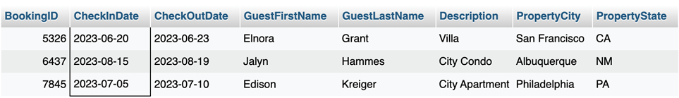

**2. Retrieve the average ratings and the total number of reviews for each property.**

SELECT D.PropertyID, D.Description, AVG(R.Ratings) AS AvgRatings,

COUNT(R.PropertyID) AS TotalReviews FROM Description D

LEFT JOIN Review R ON D.PropertyID = R.PropertyID

GROUP BY D.PropertyID, D.Description;

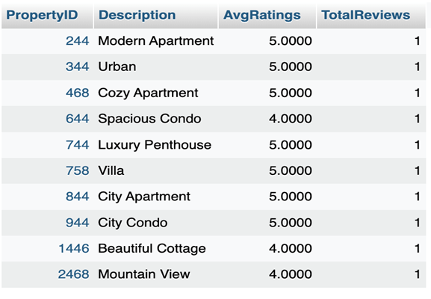

**3. Calculate the Total Points Earned by Guests.**

SELECT GuestID, SUM(GPointsEarned) AS TotalPointsEarned

FROM GuestLoyaltyProfile

GROUP BY GuestID;

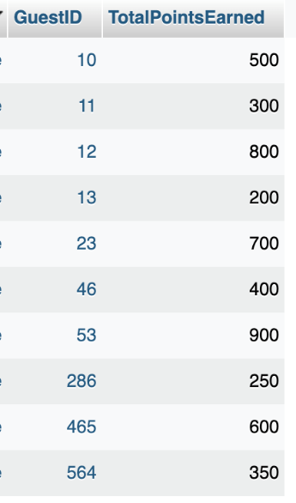

**4. Retrieve details of properties booked by guests with loyalty status ‘Gold’ or ‘Platinum.**

SELECT B.BookingID, G.FirstName AS GuestFirstName, G.LastName AS GuestLastName,

D.Description, P.PropertyCity, P.PropertyState FROM Booking B

JOIN Guest G ON B.GuestID = G.GuestID

JOIN Description D ON B.PropertyID = D.PropertyID

JOIN Property P ON B.PropertyID = P.PropertyID

JOIN GuestLoyaltyProfile GL ON G.GuestID = GL.GuestID

WHERE GL.GLoyaltyName IN ('Gold', 'Platinum');

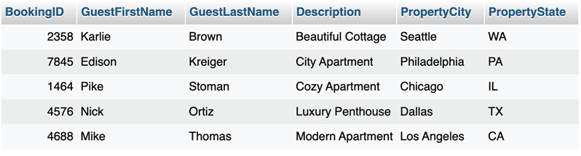

**5. Check Guests who booked with Loyalty Points.**

SELECT G.GuestID, G.FirstName, G.LastName,

B.BookingID, B.TotalPrice, B.PointsEarned FROM Guest G

JOIN Booking B ON G.GuestID = B.GuestID

WHERE B.PointsEarned > 0;

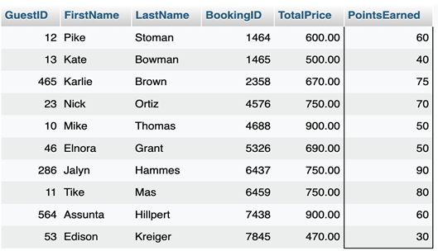

**6. Retrieve information about guests who have earned more than 500 loyalty points.**

SELECT G.GuestID, G.FirstName, G.LastName, GL.GPointsEarned FROM Guest G

JOIN GuestLoyaltyProfile GL ON G.GuestID = GL.GuestID

WHERE GL.GPointsEarned > 500;

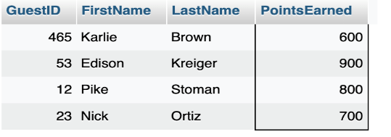

**7. Retrieve hosts with the loyalty status ‘Silver’ and their associated loyalty benefits.**

SELECT H.HostID, H.HostFirstName, H.HostLastName, HL.HLoyaltyBenefits FROM Host H

JOIN HostLoyaltyProfile HL ON H.HostID = HL.HostID

WHERE HL.HLoyaltyName = 'Silver';

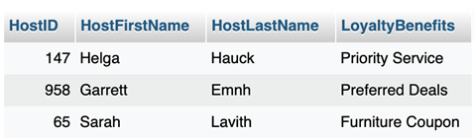

8. Retrieve the top 3 hosts with the highest total points balance in the loyalty program.

SELECT H.HostID, H.HostFirstName, H.HostLastName, HL.HPointsBalance FROM Host H

JOIN HostLoyaltyProfile HL ON H.HostID = HL.HostID

ORDER BY HL.HPointsBalance DESC

LIMIT 3;

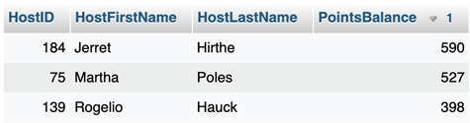

**9. Check Hosts with high total earnings.**

SELECT H.HostID, H.HostFirstName, H.HostLastName,

SUM(B.TotalPrice) AS TotalEarnings FROM Host H

JOIN Booking B ON H.HostID = B.HostID

GROUP BY H.HostID

ORDER BY TotalEarnings DESC;

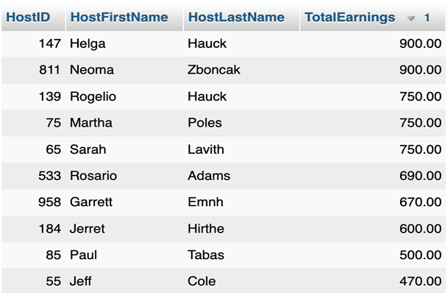

**10. List Guests in a Loyalty Tier.**

SELECT GuestID, FirstName, LastName FROM Guest WHERE GuestID IN

(SELECT GuestID FROM GuestLoyaltyProfile WHERE GLoyaltyName = 'Gold');

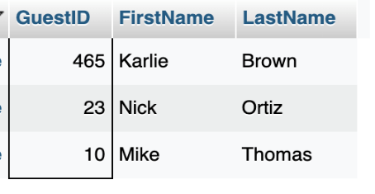

**11. Find Hosts with High Loyalty Points.**

SELECT HostID, HostFirstName, HostLastName FROM Host

WHERE HostID IN (SELECT HostID FROM HostLoyaltyProfile WHERE HPointsBalance > 500);

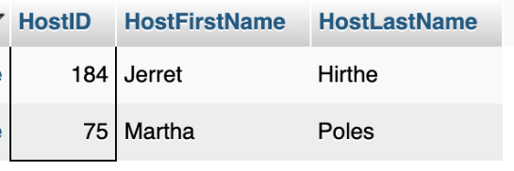

12. List Hosts with Expired Loyalty Points.

SELECT HostID, HostFirstName, HostLastName FROM Host

WHERE HostID IN (SELECT HostID FROM HostLoyaltyProfile WHERE HPointsExpired > 0);

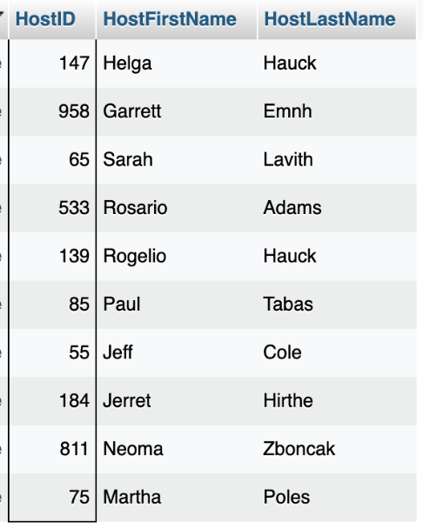

**13. Retrieve Messages between a Guest and a Host.**

SELECT MessageTimeStamp, MessageDetail

FROM Message

WHERE GuestID = 10 AND HostID = 147;

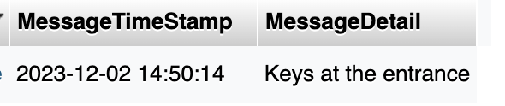

**14. Check bookings for a Guest.**

SELECT BookingID, CheckInDate, TotalPrice FROM Booking

WHERE GuestID = 10;

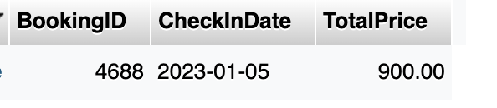

**15. Check the Loyalty Status of a Guest.**

SELECT GuestID, GPointsBalance FROM GuestLoyaltyProfile

WHERE GuestID = 46;

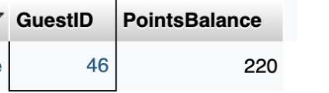

**16. Find Superhosts.**

SELECT HostID, HostFirstName, HostLastName FROM Host

WHERE HostID IN (SELECT HostID FROM HostLoyaltyProfile WHERE HLoyaltyName = 'Gold');

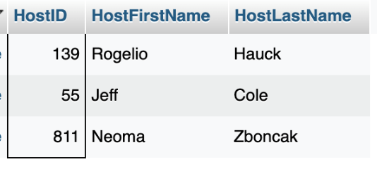

# References

Aydin, Rebecca (2019, September 20). How 3 guys turned renting air mattresses in their apartment into a $31 billion company, Airbnb. Business Insider.  
<https://www.businessinsider.com/how-airbnb-was-founded-a-visual-history-2016-2>

Bang, Christine (2023, April 10). Loyalty Programs Should Help Soften Impact of Any Economic Downturn on Hotel Sector CBRE. [Loyalty Programs Should Help Soften Impact of Any Economic Downturn on the Hotel Sector | CBRE](https://www.cbre.com/insights/briefs/loyalty-programs-should-help-soften-impact-of-any-economic-downturn-on-hotel-sector)

Dziawgo, D. (2023). Evolution of loyalty programs offered to customers and investors. Financial Internet Quarterly, 19(1), 34–47

<https://doi.org/10.2478/fiqf-2023-0004>

Lodging Staff (2019, August).  Loyalty Contribution Continues to Rise Across U.S. Hotel Bookings. <https://lodgingmagazine.com/loyalty-contribution-continues-to-rise-across-u-s-hotel-bookings/>

Pereira, Daniel (2023, June 10). Airbnb Business Model. The Business Model Analyst.  
<https://businessmodelanalyst.com/airbnb-business-model/>

Salesforce. (2019). Connected Shopper Research Report - Salesforce.com US.

<https://www.salesforce.com/content/dam/web/en_us/www/documents/datasheets/connectedshopperresearchreport.pdf>

Trivago Business Blog (2017, February 6). Loyalty Programs: The Latest Revenue-Booster for Hotels. <https://businessblog.trivago.com/loyalty-programs-boosting-hotel-revenue>

Wertz, J. (2021, September 26). The perks of a great loyalty program. Forbes.

<https://www.forbes.com/sites/jiawertz/2021/09/26/the-perks-of-a-great-loyalty-program/?sh=19bf3982b2e4>